BLUETOOTH CONTROL CAR.

Affialated by KL deemed to be University, Green Fields, Vaddeswaram.

**ABSTRACT:**

Bluetooth technology has revolutionized the way we interact with and control electronic devices, and its applications extend beyond traditional communication to innovative areas like remote-controlled vehicles. This abstract introduces the concept of a Bluetooth-controlled car, which leverages the convenience and versatility of Bluetooth connectivity to enhance mobility and user interaction. This paper explores the design, components, and operational aspects of a Bluetooth-controlled car, highlighting its potential in various domains, including entertainment, education, and automation. The discussion delves into the essential hardware and software components, emphasizing the significance of Bluetooth technology in enabling remote control and real-time feedback. Furthermore, it explores the broader implications of this technology, such as fostering STEM education, enhancing user experiences, and contributing to the development of autonomous and connected vehicle systems. The Bluetooth-controlled car represents a significant step towards harnessing wireless connectivity for the advancement of modern mobility solutions.

**KEYWORDS:**

1. Bluetooth

2. Control

3. Car

4. Wireless

5. Mobility

6. Connectivity

7. Remote control

8. Automation

9. Education

10. Technology.

**\*\* INTRODUCTION:**

The Bluetooth-controlled car project aims to explore the capabilities and potential of Bluetooth technology in the context of a remotely operated vehicle. By utilizing Bluetooth connectivity, this project leverages the convenience and versatility of wireless communication to provide a unique and engaging experience. The wirelesss control aspect not only enhances mobility but also opens up various exciting possibilities for education, entertainment, and automation.

This introduction sets the stage for a comprehensive exploration of the project. We will delve into the fundamental components and design considerations that make up a Bluetooth-controlled car, emphasizing the critical role that Bluetooth technology plays in enabling remote control and real-time feedback. The project's implications extend beyond mere entertainment, offering opportunities to promote STEM education, enhance user experiences, and contribute to the advancement of autonomous and connected vehicle systems.

affiliated with KL deemed to be university, Green fields, vaddeswaram, Guntur district-522302

**ABSTRACT:**

Bluetooth technology has revolutionized the way we interact with and control electronic devices, and its applications extend beyond traditional communication to innovative areas like remote-controlled vehicles. This abstract introduces the concept of a Bluetooth-controlled car, which leverages the convenience and versatility of Bluetooth connectivity to enhance mobility and user interaction. This paper explores the design, components, and operational aspects of a Bluetooth-controlled car, highlighting its potential in various domains, including entertainment, education, and automation. The discussion delves into the essential hardware and software components, emphasizing the significance of Bluetooth technology in enabling remote control and real-time feedback. Furthermore, it explores the broader implications of this technology, such as fostering STEM education, enhancing user experiences, and contributing to the development of autonomous and connected vehicle systems. The Bluetooth-controlled car represents a significant step towards harnessing wireless connectivity for the advancement of modern mobility solutions.

**KEYWORDS:** Here's a shorter list of keywords:

1. Bluetooth

2. Control

3. Car

4. Wireless

5. Mobility

6. Connectivity

7. Remote control

8. Automation

9. Education

10. Technology.

**1. INTRODUCTION:**

The Bluetooth-controlled car project aims to explore the capabilities and potential of Bluetooth technology in the context of a remotely operated vehicle. By utilizing Bluetooth connectivity, this project leverages the convenience and versatility of wireless communication to provide a unique and engaging experience. The wireless control aspect not only enhances mobility but also opens up various exciting possibilities for education, entertainment, and automation.

This introduction sets the stage for a comprehensive exploration of the project. We will delve into the fundamental components and design considerations that make up a Bluetooth-controlled car, emphasizing the critical role that Bluetooth technology plays in enabling remote control and real-time feedback. The project's implications extend beyond mere entertainment, offering opportunities to promote STEM education, enhance user experiences, and contribute to the advancement of autonomous and connected vehicle systems.

**2. HARDWARE REQUIREMENTS:**

1.Arduino UNO board

2.Bluetooth module

3.L293D motor driver

4.Gear motor

5.Robot wheel

7.Battery holder

8.Jumper wires

**3.Software used:**

1. **Bluetooth Connectivity**
2. **User Interface**
3. **Microcontroller**
4. **Power Source**
5. **Feedback Mechanisms**
6. **Compatibility**
7. **Range**
8. **Customization**
9. **Safety Features**
10. **App Integration**

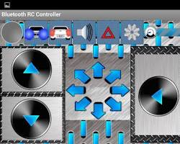

**3. CIRCUIT DIAGRAM:**

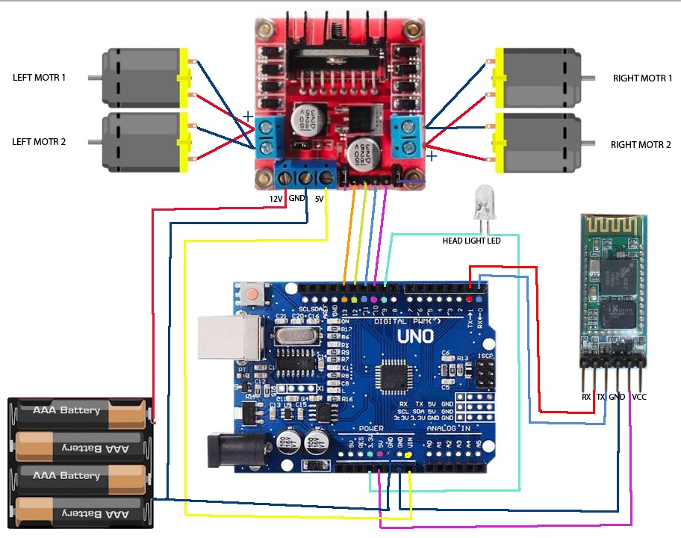

**4.RESULT:**

1. **Remote Control:** You will be able to control the car wirelessly using a smartphone or other Bluetooth-enabled device. This means you can navigate the car in any direction within the Bluetooth range.
2. **Obstacle Avoidance (if sensors are used):** If you've integrated ultrasonic sensors, your car can detect and avoid obstacles, making it an autonomous vehicle to some extent.
3. **Line Following (if line-following sensors are used):** If you've added line-following sensors, the car can follow a predefined path, making it suitable for tasks like line-following challenges or automated transportation.
4. **Customization:** You can customize the car's design, functionality, and appearance to match your preferences and needs.
5. **Education:** Building this project is an excellent educational experience for learning about electronics, microcontrollers, motors, and wireless communication.
6. **A Fun Hobby:** It can be a rewarding and enjoyable hobby project for enthusiasts interested in robotics and automation.

**4. CONCLUSION**

The Bluetooth-controlled car project represents a fascinating exploration of technology and creativity, offering a window into the potential of wireless communication, automation, and remote control. This endeavor not only provides a tangible, fun, and educational experience but also offers numerous practical applications and a sense of accomplishment.

Through the assembly of the car's chassis, the integration of motors, sensors, and microcontrollers, and the implementation of Bluetooth connectivity, we've demonstrated the power of hands-on learning in the fields of electronics, robotics, and programming. As this project unfolds, it becomes evident that the benefits extend beyond mere entertainment.

**5.REFERENCES:**

[**https://youtu.be/Pqs-3GgWW3s?si=DkeMqzEmZXPm3E7s**](https://youtu.be/Pqs-3GgWW3s?si=DkeMqzEmZXPm3E7s)

[**https://youtu.be/hI0UBvpuRTw?si=bUQIPLEkB97tZmTz**](https://youtu.be/hI0UBvpuRTw?si=bUQIPLEkB97tZmTz)

[**https://youtu.be/kewza7RyKMQ?si=M7SV7-kUnU2kyQm1**](https://youtu.be/kewza7RyKMQ?si=M7SV7-kUnU2kyQm1)

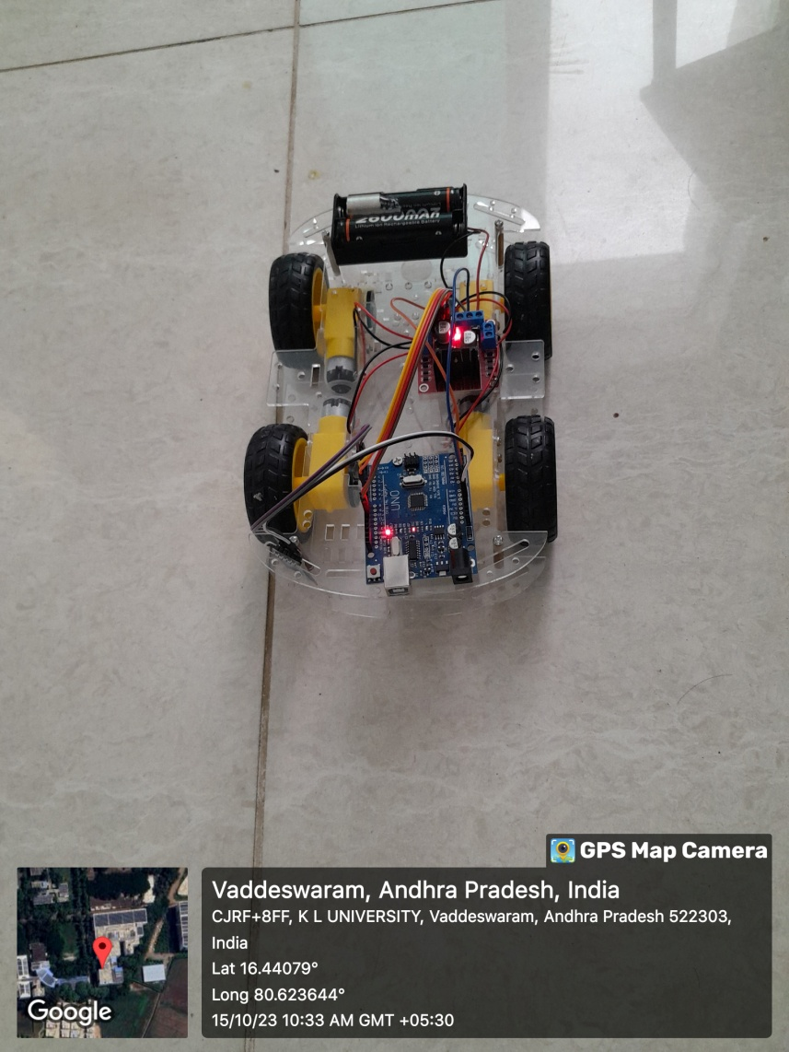

**ACKNOWLEDGEMENT:**

I would like to express my sincere gratitude to the faculty of the university for their guidance and support throughout my project on “BLUETOOTH CONTROLLED CAR”

I am truly grateful for the opportunity to have worked on this project and to have learned from such experienced and knowledgeable faculty members. I am confident that the skills and knowledge that I have gained from this project will be invaluable to me in my future career.

Thank you again to the faculty of the university for their support and guidance

**M.SATISH -2200049079**

**K.RANGA NITHEESH-2200049143**